

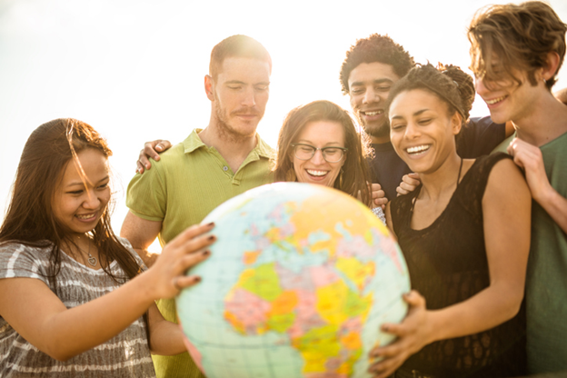

**Welcome to A-level Sociology!**

We will go through the structure of the course when you begin in September. For now, I want you to engross your mind in the following activities/tasks, complete them all and then be prepared to explore ideas and understanding of British and global society in Year 12.

If you have any questions, please don’t hesitate to contact Mr Carter at: [a.carter@ll.coastandvale.academy](mailto:a.carter@ll.coastandvale.academy)

***Task 1***

|  |
| --- |
| Society does not remain static over time; it constantly changes – through decades, centuries; and across countries, societies. Answer the following questions:  • Give 3 different ways society has changed over the last 100yrs – think about the different areas of social life and work.  • In your opinion, why has society changed? Why are societies different?  • If you were in power, what would your first four items be on your agenda? What would you hope to do? |

**Task 2**

|  |
| --- |
| Look at the statements below and then write them out in a list which ranks them in order of the one you MOST agree with, to the one you LEAST agree with.   1. Society works for the benefit of all. 2. Women are systematically disadvantaged. 3. We live in a democracy. 4. Life is unfair. 5. The world is run for the benefit of a very small group of people. 6. Most people cannot see that they spend their entire lives being exploited. 7. Structures in society exist to help people and the smooth operation of society. 8. Men dominate. 9. Gender inequalities exist. 10. People are judged only in terms of their merit / skills / intelligence.   Take the one from the top and bottom and for each, write a developed paragraph explaining why you placed it where you did. Please follow this writing frame: I most agree/disagree with the statement________. This is because …. Evidence to support this includes… Furthermore….. Therefore, it is clear that (insert statement) is…. (Valid? |

**Identity - Task 3**

What makes up your identity? What makes you who you are? Create a mind map showing all the influences on your identity.

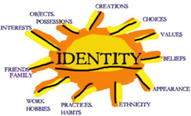**Identity** is about how we see and define ourselves –our personalities – and how other people see and define us. Many aspects of our individual identity are influenced by **agencies of socialisation**. These are structures or groups of people.

2. Suggest between 5 and 10 examples of social structures or groups of people that impact upon you (e.g. family, education, peers, media etc.)

3. Which of these social structures or groups influence you most? Does it depend on your age as to when they are more influential? Does it depend on other factors such as your gender or social class? Explain your answers.

**Nature v Nurture - Task 4**

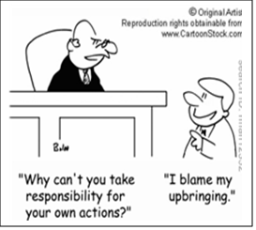***Nature vs Nurture – The Big Debate***

There are many ways of explaining why certain people do things in certain ways. For example, biologists think that people behave as they do because they are controlled by nature. This is known as **Nature theory**. Humans are compared to animals and seen to act on **instinct**.

Sociologists believe that people behave as they do because they are taught how to behave. For example, the sociologist Michael Haralambos states, ‘Human beings learn their behavior and use their intelligence whereas animals simply act on instinct.’ This is known as **Nurture theory**. Nurture means the way you are brought up. It is also a reference to **socialization**, the lifelong process by which we learn our culture, values, norms and how to behave.

**Write down** a list of things that you were taught by other people about how to behave eg. how to speak etc.

**TASK 5**

What makes us Human? **Think** about your answers to the questions below:

• Are we meant to live alone?

• What would a person be like if they grew up without human contact?

• What would a person be like if they were then introduced into a society?

• Do we need a society in which to survive?

• Can someone be truly human if they grew up without human contact?

• Are we ruled by our instincts? (An instinct can be defined as a complex, unlearned pattern of behaviour that is universal in a species).

**Discuss these with friends and family**. Sociology recognises that as members of society we have to learn ‘human’ behaviour and this is done through a variety of social institutions and social groups right throughout our lives. Sociologists challenge the focus on the ‘nature’ side of the debate theories for two particular reasons. Firstly, people acted differently in the past from the way that they do today. They had different ideas and different beliefs. If it were ‘natural’, we would see little change in human behaviour throughout History. Furthermore, anthropology is the study of different human societies. Wherever you go in the world, people act differently from the way they do in Britain. This suggests again, that human behaviour cannot simply be ‘natural’ as it would be the same the world over. **Task:**

**In MAX 300 words, answer the question – *What makes us human?***

**Task 6 - Britain**

Have a look at this guide offered to advise people on British ‘norms’ to help them adjust to British life, if coming here to study. <https://www.studying-in-uk.org/british-culture-and-social-norms/>

Your task is to create your own ‘Guide to British Culture’. This can take any form that suits you; booklet, poster, video etc. Consider the expected and accepted behaviour (norms) and ideas (values) that you’d see from the people of Britain, if visiting for the first time.

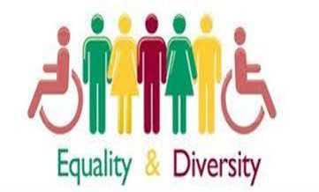***Task 7: Mini-Essay***

A-level Sociology is all about essay writing, a hugely important skill. This essay is designed to allow you to demonstrate your sociological understanding and writing skills.

**Essay title:**

**Evaluate the view that society is becoming more equal in the 21st century.**

With a maximum of 500 words, outline how you feel it is becoming more equal, how it isn’t and reach a judgement on just how much more equal or otherwise Britain has become.

**OPTIONAL TASK:**

Read and make notes on a thinker of your choice from “History of Western Philosophy – for ideologies”