Summer Transition Task

A Level History

***Martin Luther King made the greatest contribution to Civil Rights, how far do you agree with this view?***

The essay question above will be one of the first essays you will complete as we study Civil Rights. As we go through the course, we will look at different Civil Rights Leaders and assess their impact on Civil rights.

**TASK ONE**

To prepare you for your first term studying Civil Rights, , we would like you to research the contribution of the following leaders. I would advise to summarise the work of each of them, noting down their contribution to Civil Rights. In the past some students have put this onto a PPT, with no more than a slide per individual. This allowed them to add to their notes as we progressed along the course.

**Who are the key individuals I must research?**

* **Martin Luther King**
* **Jesse Jackson**
* **Booker T Washington**
* **Du Bois**
* **Frederick Douglas**
* **Blanche K Bruce**
* **Ida B Wells**
* **Ralph Abernathy**
* **Malcolm X**

Who has put up the greatest barrier in preventing African Americans gaining their civil rights?

We will also be looking at those individuals who created obstacles in advancing Civil Rights. Create a mind map noting who each of the following are and how they resisted Civil Rights.

* Nathanial Bedford Forrest
* Andrew Johnson
* Woodrow Wilson
* Eugene Connor

**TASK TWO**

**The Federal government had a large part to play in the development of Civil Rights from 1865-1992. Some presidents championed the work of Civil Rights Leaders whilst others vetoed every bill that was put forward.**

You are not expected to know all of the presidents, only those who made a contribution to Civil Rights. You need to be aware of which helped and which hindered for all 4 topics.

There have been several questions that include the contribution of the presidents, and some that focus specifically on their work alone.

For example:

* To what extent did the work of the presidents hinder the development of African American Civil Rights 1865-1992

Step one: You will need to include the presidencies of the following presidents on a timeline from 1865-1992

You should be aware of which party they belonged to and time they spent in office

* Reagan
* Nixon
* LB Johnson
* Johnson
* Kennedy
* Lincoln
* Eisenhower
* Roosevelt
* FDR
* Hoover
* Bush
* Truman Carter
* Wilson

**TASK THREE**

You have been asked to create a short obituary for an individual and group of importance for the civil rights movement across this period of time. Choose 1 person and 1 group to create a no less than 250/no more than 350 words.

|  |  |
| --- | --- |
| **PEOPLE** | **GROUPS/ORGANISATIONS** |
| * Abraham Lincoln * Booker T Washington * Martin Luther King Jr * Malcolm X * Stokely Carmichael * Philip Randolph * Franklin D Roosevelt * Cesar Chavez * John Collier | * NAACP * Nation of Islam * Knights of Labor * Congress of Industrial Organisations * Industrial Workers of the World * Native American Rights Fund * National Organisation for Women |

The following films and documentaries are a supplementary list of resources **(and not compulsory).** They give a good insight into American political life and historical events. They do not replace your academic reading and research

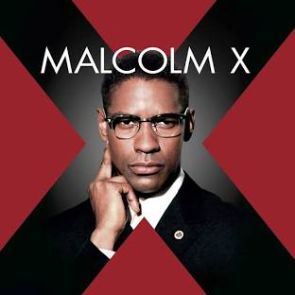‘**Hidden Figures’** is based on the true story of three African-American female mathematicians who worked for NASA during the Space Race of the early 1960s. These women were ‘human computers’ and the film tells their story within a male dominated work-place and a still segregated society.

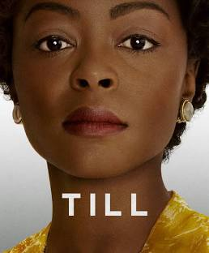**Malcolm X** Biographical epic of the controversial and influential Black Nationalist leader, from his early life and career as a small-time gangster, to his ministry as a member of the Nation of Islam and his eventual assassination

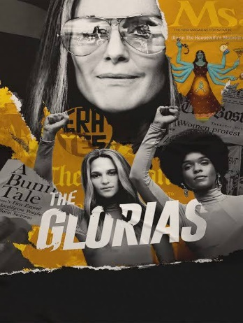**Till** is a profoundly emotional and cinematic film about the true story of Mamie Till Mobley's relentless pursuit of justice for her 14 year old son, Emmett Till, who, in 1955, was lynched while visiting his cousins in Mississippi. In Mamie's poignant journey of grief turned to action, we see the universal power of a mother's ability to change the world.

**The Glorias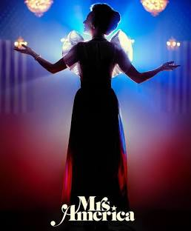:** The story of feminist icon Gloria Steinem's itinerant childhood and its influence on her life as a writer, activist and organizer for women's rights worldwide.

**Mrs America:** Conservative activist Phyllis Schlafly leads an unexpected fight against the Equal Rights Amendment movement during the 1970s.