Welcome to Psychology!

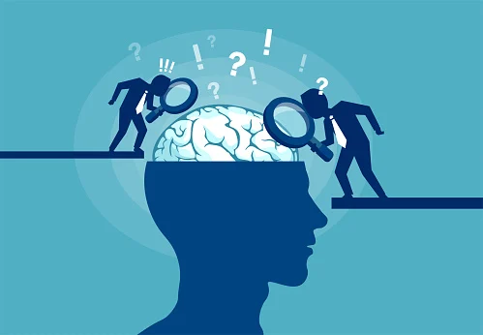

Congratulations on choosing to study A-level psychology at Lady Lumley’s Sixth Form! This marks the start of your journey of learning and understanding who we are as humans and why we do the things we do.

A-level psychology focuses on how we study the brain and human behaviour. We develop critical thinking skills, essay writing skills and learn research methods to help us understand psychological studies and theories. In psychology we cover lots of new and interesting topic areas as shown below:

|  |  |
| --- | --- |
| **Year 12**   1. Memory 2. Social influence 3. Attachment 4. Approaches 5. Clinical psychology and mental health 6. Research methods | **Year 13:**   1. Issues and debates 2. Biopsychology 3. Cognition and development 4. Schizophrenia 5. Forensic psychology |

You will be studying AQA Psychology. The psychology A-level is 100% exam based. You will sit 3 papers at the end of year 13, lasting 2 hours each.

Psychology aims to provide students with an understanding of their own lives through psychological research. The course encourages students to think critically regarding contemporary society. The fundamental purpose of psychology is to understand why and how we behave in the ways that we do: from social influence to criminal behaviour.

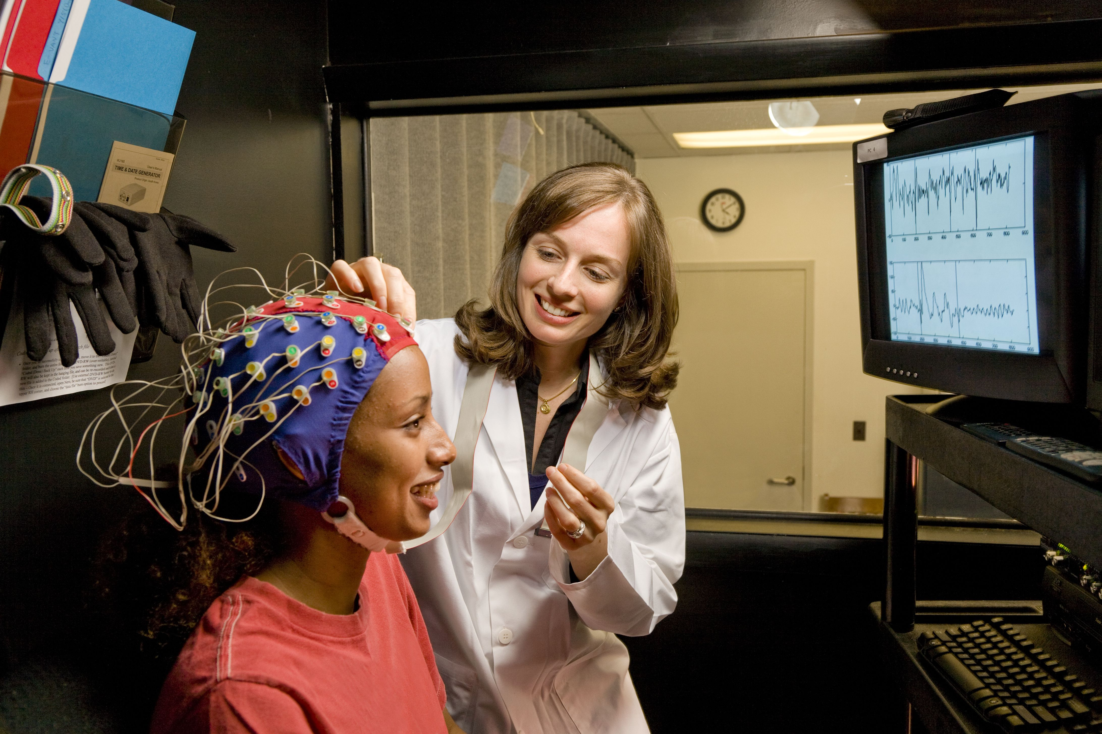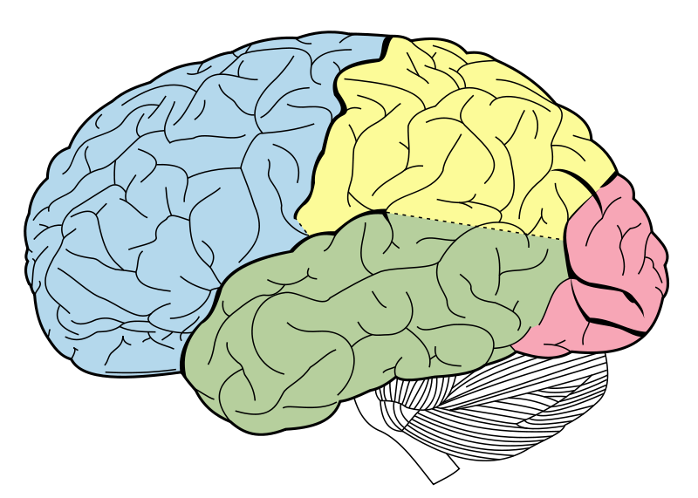

Psychology provides students with a wide range of transferable skills such as; analytical thinking, writing skills, and the ability to problem solve and challenge your peers' opinions. All of these skills are needed for both university and employment.

Psychology is a subject which underpins the understanding of most areas of our lives and provides students with a foundation of knowledge of our behaviour. Due to this we have had students go on to study not just psychology, but also law, policing, nursing, medicine, economics, teaching and business studies.

Nearly 50% of all the work needed to do well at A-level will take place outside of lessons so prepare for lots of independent learning in year 12 and 13. This is not a filler subject; it requires full commitment, passion and endurance.

Within this pack I have included a range of tasks for you to complete in order to prepare you for September. It is crucial that these tasks are complete ready for our first lesson together.

I look forward to our first lessons in September together!

Mrs Streets 😊

**Task 1: Your personality**

<https://www.16personalities.com/>

Take the personality test on this website and summarise your results on 1 page of A4 with a photo of yourself on the sheet and your name. For example, I am a “defender” which suggests that I am an introvert and gain energy from time on my own. It also suggests that due to this personality trait, am highly caring of others and very loyal!

* Do you agree with the results? Are the results accurate of you?
* What can the results tell me about you?
* Write a brief overview of your results stating what personality type you are, what it represents and how others can work with you based on your results.

**Task 2: Individual Research**

As psychology is a new subject it is important that you understand what the subject is.

* What is psychology?
* What do psychologists do and what can they offer us?
* Name one famous psychologist and explain why they are famous.
* What jobs can psychology lead you to?
* Why do you want to study psychology?

**Task 3: Introduction to memory**

Our first topic in September will be memory, studying how the brain can remember memories and what happens when we forget things?

Watch the video of Clive Wearing <https://www.youtube.com/watch?v=Vwigmktix2Y> and do any additional research needed to answer the following questions:

1. How is Clive’s memory impaired?
2. What can Clive remember? Try and categorise his memories and behaviours here
3. How did Clive lose his memory?
4. What does Clive’s case tell us about memory? Can it be used to explain how memories are stored in the brain?

**Task 4: Conduct a memory experiment!**

A big part of psychology is learning how to research and conducting experiments (we will do some in class in year 12!) As our first topic is memory, conduct this simple memory experiment on yourself, family and friends over the summer holidays (aim for at least 10 people). Then answer the questions below.

Give your participants 2 minutes to memorise as many of the words in the grid as they can. Then ask them to write down as many as they can remember.

Grid 1

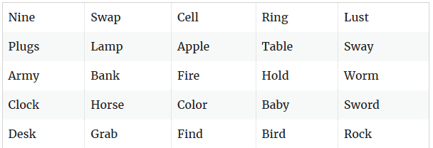

Give your participants a second grid of words to learn for 2 minutes, then have them recall as many words as they can remember once again.

**Grid 2**

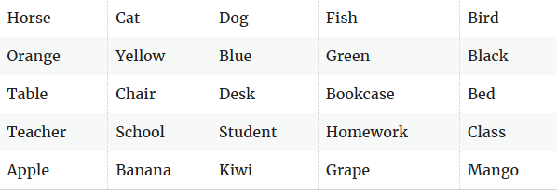

1. Plot a simple bar chart of your results – what does this tell us about recall of words?
2. Find the average of how many words were correctly recalled in grids 1 and 2. Which grid was easier to remember? Why might this be?
3. Did any of your participants include words from the first grid when recalling words from the second grid? There is a name for this phenomenon – see if you can find out what it is called!
4. Can you think of any ways to improve this experiment? How could it be made more accurate or fair?
5. What do the results of your experiment tell us about how our memory works?

**Task 5 – Psychology in the media**

Psychology often features in films, tv shows, podcasts, books and even on social media. There are some more accurate descriptions of how our brain and behaviour work and some media exaggerate what the brain can and cannot do!

Look at the suggested list of media – watch/listen or read at least 2 of the choices from the list and be prepared to feedback on how these link to psychology in September!

**Films**

* **12 Angry Men** – the film is a powerful look at social influence and how law and order can rely on the power of minority influence.
* **Memento** – a man with short term memory loss attempts to find the man who murdered his wife – if he can remember where to start looking
* **A Beautiful Mind** – based on the true story of John Nash and how his mind works throughout his life
* **The Truman Show** – the psychology of who we are and the choices we make are explored in this psychological comedy.
* **Good Will Hunting** – the film looks at what it means to be gifted but also into the importance of attachment and therapeutic relationships.

**Tv shows and documentaries**

* **Channel 4 mental health documentaries -** <https://www.channel4.com/collection/mental-health-matters>
* **BBC psychology of the mind clips -** <https://www.bbc.co.uk/programmes/p01xkr8n>

**Books**

* **The Skeleton Cupboard by Tanya Byron** – Part autobiographical, clinical psychologist Tanya Byron talks through how she became a psychologist and some of her most complex cases.
* **Psychology, a very short introduction** by Freda McManus and Gillian Butler – a brief but great introduction to psychology as a subject
* **Opening Skinner’s Box by Lauren Slater** –investigations into some of the psychology experiments that have changed how we view the world
* **Quiet: The Power of Introverts in a World That Can't Stop Talking** by Susan Cain – great discussions around personality
* **Forensic Psychology by Adrian Scott** – a detailed account of many studies of forensic psychology and how criminals minds work

**Podcasts and TED talks**

* **10 myths about Psychology, debunked.** Available at: <https://www.youtube.com/watch?v=0V5zivq-F7s>
* **Martin Seligman: A new era of positive psychology**. Available at: http://www.ted.com/talks/martin_seligman_on_the_state_of_psychology
* **Carol Dweck: The power of believing that you can improve.** Available: https://www.ted.com/talks/carol_dweck_the_power_of_believing_that_you_can_improve?language=en
* **All in the mind, BBC sounds.** Available at: <https://www.bbc.co.uk/programmes/b006qxx9/episodes/player>
* **Two Guys on Your Head, NPR.** Available at: <https://www.npr.org/podcasts/381443482/two-guys-on-your-head>

**Bonus tasks!**

If you are really keen to get stuck into psychology over the summer, there are some short online courses you can do to give you a good introduction to psychology.

All courses are free of charge, but you may need to create a free account to save your progress with each course.

<https://ondemand.tutor2u.net/students/introduction-to-aqa-a-level-psychology>

https://ondemand.tutor2u.net/students/transition-to-aqa-alevel-psychology-skills-booster

<https://www.open.edu/openlearn/health-sports-psychology/psychology/starting-psychology/content-section-0?active-tab=description-tab>